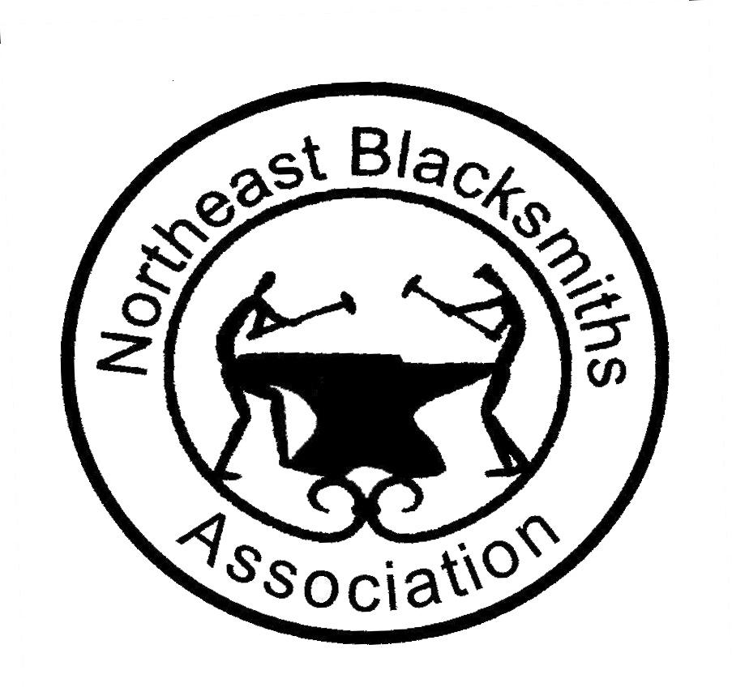
Spring 2018 Hammer-In at Ashokan

SCHEDULE OF EVENTS

Friday April 13th
2:30 PM- Arrival, registration, and tailgating
4:00 PM- Shop and pavilion set-up
6:00 PM -Buffet Dinner & Registration
7:30 PM to 9:00 PM-Presentation by Nick Rossi, Performance Hall

Saturday, April 14th
8:00 AM –Breakfast
8:30 AM- Day Guest arrival and registration
9:00 AM to 12:45 PM -Shop: Demonstration by Nick Rossi
Pavilion: Intro. to equipment, fire tending, and hands-on forging skills
12:45 PM-Lunch
1:30 PM to 2:00 PM-Iron-in-the-Hat drawing, Forging contest judging
2:00 PM to 5:30 PM-Shop:Demonstration by Nick Rossi
Pavilion: Hands -on basic forging skills continued
5:30 PM-Dinner
7:00 PM-Chapter business meeting
.
Sunday, April 15th
8:00 AM -Breakfast
8:45 AM Check out of bunk areas
9:00 AM to 11:30 PM –Final demo / wrap up with Nick Rossi
Pavilion: Hands -on basic forging skills continued
11:30 AM to 12:00 PM-Shop and pavilion clean up
12:00 PM-Lunch
1:00 Departure

